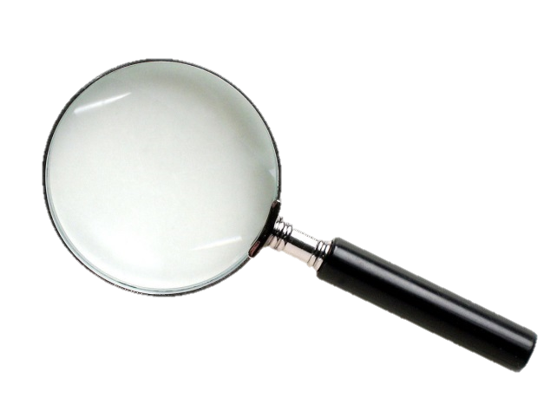
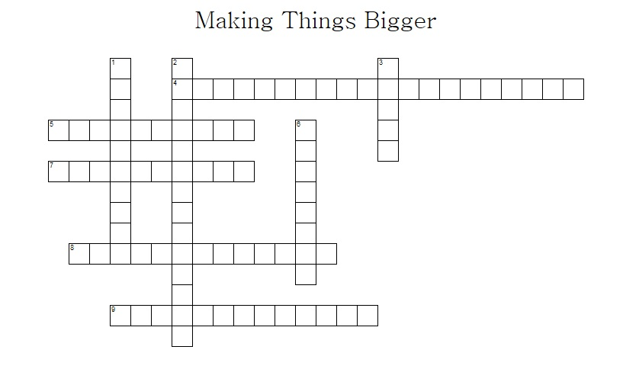

ACROSS

 | 4. | a light microscope that has two ocular lenses
 | 5. | one-thousandth of a millimetre
 | 7. | when a scientists cuts apart a dead plant or animal to study it
 | 8. | the amount of the specimen seen through a microscopic / describes objects that can only be seen using a microscope
 | 9. | the amount by which the image is magnified (made bigger) compared to the real object (specimen)
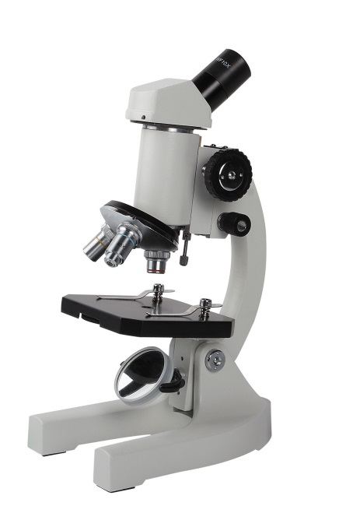
DOWN

 | 1. | instrument used to make very small things look bigger
 | 2. | the lens of the microscope closest to the stage
 | 3. | what is seen using the microscope
 | 6. | the object being looked at through the microscope
field-of-view binocular-microscope microscope
specimen micrometre dissection
objective-lens image magnification

